**Practice questions-2**

1. **Common Mode Filter**

A certain equipment under test (EUT) working with a 230 Vac supply, drawing 10 A current, is sensitive to common mode noise at 100 kHz. The EUT malfunctions if the magnitude of the common mode noise on the power leads is more than 10 mV. In CS 101-1 test, common mode noise of 110 dBμV is injected on power leads. It is required to design a common mode filter so that the unit complies to CS101-1 test. Y type capacitors to 80nF are connected from each line to earth.

Design the inductor in following steps

(i) Calculate the impedance (only the magnitude is relevant in this example) offered by capacitors.

(ii) Calculate the suppression required to conform to the CES 101-1 test.

(iii) Compute the Impedance offered by the inductor. Calculate the value of inductance

(iv) Select suitable core from given graphs/ tables.

Give an argument that the Inductor power is not the deciding factor for the core size.

Also comment on whether system current of 10 A saturate the core

Draw a diagram of winding method.

(v) Calculate the number of turns.

**Ans:**

(i) Impedance (magnitude) offered by capacitor is 

(ii) 110 dBμV≈300mV. This is 30 times more than the tolerable common mode noise by the EUT.

Therefore, suppression should be a factor of more than > 30 OR > 29.54 dB (≈30 dB)

(iii) The required impedance offered by the inductance is 580Ω (29 X 20). We plan it to be 600 Ω

*Z= jωL=*600 🡺 954*μH* ≈ 1 mH

(iv) The inductor power 

At flux density of 100 mT the volume works out to be 2.5 mm3 !

Any small bead also works. However, In this case, we have 10 A current being flown through the wires. Therefore, the core should be big enough to have space for the current.

The current of 10 amp does not saturate the core as the flux due to the supply and the return cancels each other. See diagram.

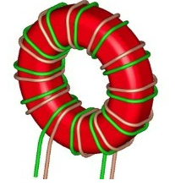 

No of turns are given by





We select the core **EI 28-20**

* *N2=198.94 🡺 N≈14*



**(6H20)**

**Power handling capacity of the material**

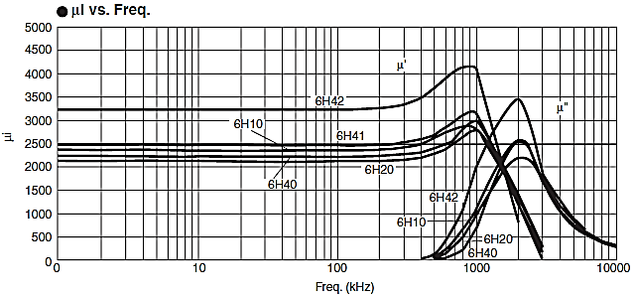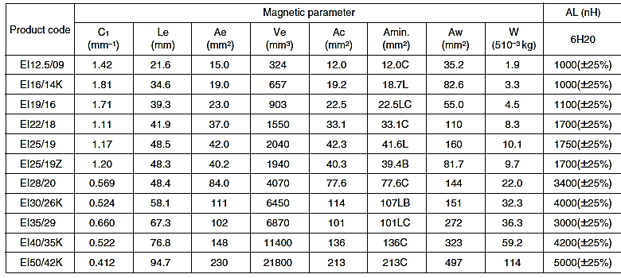

**Data of the available cores**

**Initial Permeability**

1. **CE due to switching subsystems like SMPS, Pulse width/ modulating control devices.**

A Switched Mode Power Supply (SMPS) switches current of 10 A at 50 kHz with duty cycles between 10 to 90 %. Assume rectangular pulses and no filtering, draw Conducted Emission (CE) spectrum at 10%, 30% 60% and 90% duty cycle.

10A

I

Time

20ms

6ms

3A

I

Frequency

166kHz

50 kHz

Sinc Envelope

-166kHz

10A

I

Time

20μs

2μs

1A

I

Frequency

500kHz

50 kHz

Sinc Envelope

-500kHz

**10 % PWM**

**30 % PWM**

10A

I

Time

20μs

12μs

I

9A

I

Frequency

55.5kHz

50 kHz

Sinc Envelope

-55.5kHz

10A

I

Time

20μs

12μs

I

6A

I

Frequency

88kHz

50 kHz

Sinc Envelope

-88kHz

**90 % PWM**

**60 % PWM**

Observe the magnitudes of frequency components

The test condition require that the CE radiation at 150 kHz to be below 100dBμABy what factor does this CE emission need to be suppressed if the system is operated at 60% duty cycle. (Make suitable numerical approximations.)

Computation of 3rd harmonic component at 60% duty cycle.



Therefore, the CE emissions need to be suppressed by > 9.05 dB or by a factor more than 8.969.

1. Compute the Eddy current loss in the iron core transformer if the primary has 10 turns (*N*) and has sinusoidal current is 10 A (*I*) at 50Hz. The core cross section (Aeff) is (1 cm X 1cm) and the magnetic circuit length (*l*) is 40m. Calculate the eddy current loss if the resistivity of the core is 9.71 X 10-8 Ωm. And the density is 7900 kgm-3. Will it be different if the core is formed by 100 sheets of 0.1 mm each? Relative permeability (***μr***)of iron is 5000.

**Ans**:

1. We compute the magnetic field due to the primary current.

MMF=*Hl= B/*(*μ0μr*)Therefore,

Peak Magnetic field *Bp* ={X*N* X *I* X (*μ0μr*)}/*l*

= (1.4142X 10 X 10 X 1.2566 X 10-6 X 5000)/0.4 =2.221 *T*.

1. The mass of the core= Volume X density= 7900 X 0.4 X 10-4=0.316 kg.

The empirical formula for the eddy current is



So the eddy current loss in the core is 2644 X 0.316 =835 Watts

When we form the core by 100 think stampings, loss per sheet will reduce to= 0.2664 W.kg-1 (factor *d2*)

Such 100 sheets will give total power loss to 26.44 watts.

(Hence eddy loss/ iron loss reduces by factor equal to No. of stamping sheets)

1. The equipment under test (EUT) has a subsystem containing a sinusoidal oscillating current element of length 10 cm carrying current of 10 A, at 20 KHz. Assume that it also generates magnetic flux density of 0.025T.
2. Compute the electric field strength at 1 mm from current element. Assume that the subsystem acts like ***E*** field source with that strength.

Design an enclosure to shield this radiation for compliance to RE 102 (Limit of 55 dBμVm-1@ 20 kHz) and RE 101(limit 80 dBpT @20 kHz).Design aluminum enclosure of appropriate thickness. The engineering conditions require that the distance between the subsystem and enclosure is 1mm.

1. What is the suppression required in the *E* field? Compute the reflection and absorption loss.
2. What is the suppression required in the *H* field? Compute the reflection

Make

**Ans**:

1. Electric field at face of the shield (using ‘E field due to **Hertzian dipole)**



This electric field signal needs to be suppressed by at least **87 dB.**

The total **Shield effectiveness**= SE (dB) = R1(dB)+ A(dB) + R2(dB)= 2R1(dB)+ A(dB)

We compute each term. It is near field condition (*r* < λ/2π)

Relative conductivity for Aluminum🡺***σ****Cu*=5.96 X107 and ***σ****Al*=3.8 X 107🡺 ***σr(Al)*=**0.637



This is much higher than the E field suppression requirement.

Magnetic flux density is

We take equivalent flux density of 0.025 T= 207.95≈208 dBpT

Now for compliance, we need suppression of at least 128 dB!

The magnetic field suppression



Aluminum enclosure in fact increases the magnetic field.

 Required thickness is 9mm.!

This is impractically large.

Therefore, shielding is done with ferromagnetic material.

Lets use iron (μr=5000). Specialized materials may give dramatic reduction in size.

***σ****Cu*=5.96 X107 and ***σ****Iron*=1X 107🡺 ***σr(lron)*=**0.1677 and ***μr(Iron)=***5000



Hence the thickness for A=128 dB is (t)= 2.3 X10-4. This gives 0.23mm

This will give the value of *R1m*=32.6 dB.

This will allow to design for absorption loss of 96. We design for 100 dB (with little safe margin).

We get t=

With this advantage it is possible to get still thinner sheet (t≈0.18mm)

The values of *R1m* will also change to 214 dB. However, it still remains much more than expectation.

1. In a large installation the earthling-strip (with cross section 3mm X 33.33mm) as extra length of 62.8 m and it is advised not to cut this strip considering future need. There are 3 options for earth pit arrangements. Select the appropriate one.
2. At nearest point (say at distance of 1 m) and the extra length is kept open ended after the earth connection.
3. Make a coil (of radius 1 m and connect the other end to earth pit).
4. Lay the strip straight and make the pit at 62.8 m from the installation.

Justify the answer by calculating the resistance and inductance in every case.

(Neglect the ration aspect of the arrangements)

Resistivity of copper= 1.68 X 10-8. Cross section area= 10-4m2.

Resistance = ρl/A🡺 Case (a) = (1.68 X 10-8 X 1)/10-4=1.68 X 10-4.

1. and (c) = (1.68 X 10-8 X 62.8)/10-4=1.055 X 10-2.

Inductance=

Case (a)



= 0.903 μH

Case (b) 1 in= 25.4 mm , assuming pitch of the coil is 5mm. length 50mm≈2in.

L= (R2 XN2)/ (9r +10d) =(39.372 X102)/{(9 x39.37)+10 X 2)}

= 42.44μH

Case (c)



=108 μH

Hence option (a) is the best.

(Though the strip resistance is very low, iIt is better to make a coil and connect the other to earth pit)

Option B is the worst as it offers higher inductance and will delay earthing action.

1. Assuming that the cell phone is held in close proximity while listening to a call.

Assume that the RF power was 2 W. The conductivity human tissue0.95 Sm-1

Specific heat capacity is 3.6 kJ.kg-1 0K-1 and the density is 1200 kg.m-3.

Calculate the Temperature rise of the tissue if it is used for 15 minites. What is the SAR valueof the cell phone?

2 Watt of power = E2/377 🡺 27.45 V.m-1

Now, 

Now the temperature rise=